Lesson 5 Demo 13: Mount Volumes via Swarm Services

This section will guide you to:

* Mount volumes in Docker

**Step 1:** Create a Docker volume

*sudo docker volume create my_vol*



**Step 2:** Start the container with a volume

*sudo docker run -d --name myweb1 -v my_vol:/var/www/html nginx*



*sudo docker run -d --name myweb2 --mount *

*src=my_vol,dst=/var/www/html nginx*

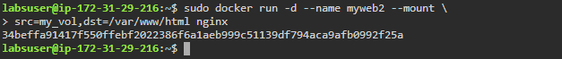

**Step 3:** Remove the containers

*sudo docker rm -f myweb1 myweb2*

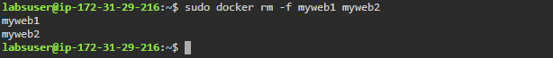

**Step 4:** Create containers and use bind mounts

*sudo docker run -d --name myweb1 -v *

*type=bind,source="$(pwd)"/html,target=/var/www/html nginx*

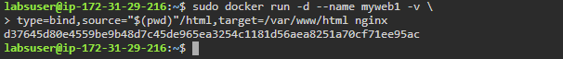

*sudo docker run -d --name myweb2 -v *

*"$(pwd)"/html:/var/www/html nginx*

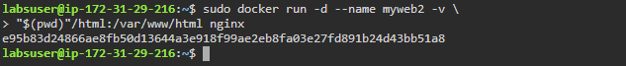

*sudo docker run -d --name myweb3 -v *

*"$(pwd)"/html:/var/www/html:ro nginx*



**Step 5:** Remove the containers

*sudo docker rm -f myweb1 myweb2 myweb3*

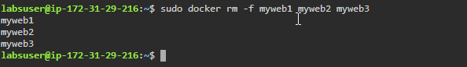

**Step 6:** Create temporary ram-based file system

*sudo docker run -d --name myweb1 *

*--mount type=tmpfs,destination=/app nginx*

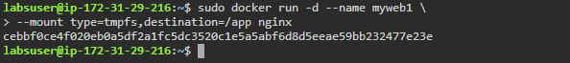

*sudo docker run -d --name myweb2 --tmpfs /app nginx*



**Step 7:** Remove the file system

*sudo docker rm -f myweb1 myweb2*

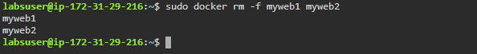

**Step 8:** Create a container from *alpine* image with **my_vol** volume

*sudo docker run -it --name webapp -v my_vol:/var/www/html alpine*

**Step 9:** Inside the alpine container, execute the following commands to create three files inside the */var/www/html* directory

*cd /var/www/html*

*touch test1 test2 test3 && mkdir testdir*

*exit*

